**PROBLEM SOLUTION FIT**

**DOMAIN:** IoT

**Project Title:** Smart Farmer – IOT Enabled Smart Farming Application

**Team Members**:

1)Afrin Jumana M (913119106005)

2)Srinithi A(913119106109)

3) Jeeva Getzie Cynthia A (913119106038)

4)Priya M(913119106079)

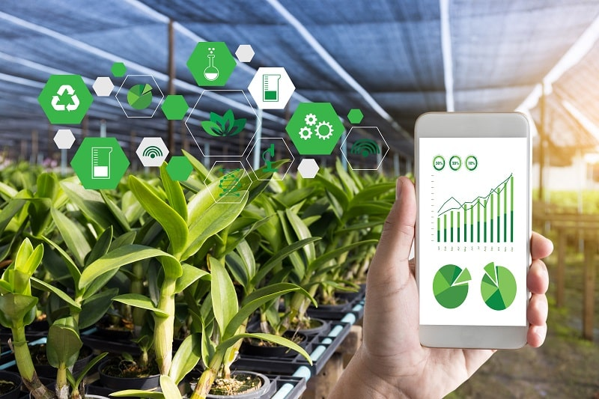

**Problem-Solution Fit**

**Explore AS, differentiate**

**Focus on J&P, tap into BE, understand RC**

**Deﬁne CS, ﬁt into CC**

**Focus on J&P, tap into BE, understand RC**

**AS**

**5. AVAILABLE SOLUTIONS**

**CC**

**6. CUSTOMER CONSTRAINTS**

**CS**

**1. CUSTOMER SEGMENT(S)**

Who is your customer?

i.e. working parents of 0-5 y.o. kids

For smart farming, lot of iot based solutions are there. But ,one huge disadvantage of smart farming is that it requires an unlimited or continuous internet connection to be successful. This means that in rural communities, especially in the developing countries where we have mass crop production, it is completely impossible to operate this farming method. In places where internet connections are frustratingly slow, smart farming will be an impossibility.

And also It requires an understanding of robotics and ICT. However, many farmers do not have these skills. Even finding someone with this technical ability is difficult or even expensive to come by, at most.

The main customer for our project are:

i)Farmers who wants to improve the yield of their crops.

ii)Farmers who wants to know the condition of their crops and it’s environmental conditions so they could take the necessary methods immediately.

Network connectivity would be the main constraint as we use Wi-Fi which has major limitations like in coverage, scalability and power consumption.

**BE**

**7. BEHAVIOUR**

**RC**

**9. PROBLEM ROOT CAUSE**

.

**J&P**

**2. JOBS-TO-BE-DONE / PROBLEMS**

.

IoT applications help farmers to collect data regarding the location, well-being, and health of their crops.

Weather stations equipped with smart sensors can collect weather data and send useful information to a farmer.

As in the case of weather condition monitoring, sensors for crop monitoring also collect all information like crop health, humidity, precipitation, temperature, and other parameters.

Technologies keep developing but still the farmers are not able to achieve their goals(i.e.) receiving the expected profit due to various reasons like the presence of excess water in the field, varying climatic conditions etc which affects the crop. So in order to avoid this there is a need for smart farming which helps to improve the time efficiency,crop monitoring,soil management etc.

1)The farmers will initially find it hard to use the device as they have to get familiar with the technologies.

ii)They must be with their phone/laptop always so that they would be alarmed when they get the message/mail.

iii)Our main job would be making the technologies feasible for the farmers by bridging the gap.

|  |  |  |  |  |
| --- | --- | --- | --- | --- |
| **Identify strong TR & EM** | **3. TRIGGERS TR**  Customers get triggered mainly because to save their crops and to prevent them from the damage as they feel depressed when they face the losses and it indirectly affects their family too. This device is also a budget friendly device.  . | **10. YOUR SOLUTION SL**  To provide an alternate (i.e) to avoid the network problems we are also going to introduce the manual mode where the farmers can stop the water flow /provide limited amount of water flow into the field., Make it more user friendly(like appoint the help center team to guide them whenever they are facing any trouble with our app),..  Additional features like create an awareness about where to get agricultural loans, government agriculture schemes and get the feedback of every farmers on every monthend and if its related to government, then make it to reach the government. It also ensures whether the crops are well nourished and watered without human intervention. It helps in increasing farming productivity and quality, reducing labour costs and maintaining the sustainability of the entire value chain. | 1. **CHANNELS of BEHAVIOUR CH**   Offline:  The IoT-based smart farming not only helps in modernizing the conventional farming methods but also targets other agriculture methods like organic farming, family farming (complex or small spaces, particular cattle and/or cultures, preservation of particular or high-quality varieties, etc.), and enhances highly transparent farming.  Online:  IoT-based smart farming is also beneficial in terms of environmental issues. It can help the farmers to efficiently use water, optimize the inputs and treatments | **Extract online & ofﬂine CH of BE** |
| **4. EMOTIONS: BEFORE / AFTER EM**  Before:  Depressed ,loss of time ,Facing more losses  After:  Confident , Gets chance to spend time efficiently,95% profit. |